Welcome to Space Shooter!

This is your character image! Use the W, A, S, and D keys on your keyboard to move around the rooms and defeat the evil Moonbots!

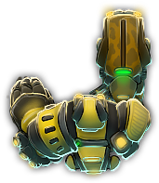

These are the evil Moonbots! Don’t let them touch you, or you will lose some of your precious health!

 

To fire your laser cannons, click and hold the left mouse button and position the cursor on the screen in the direction relative to your player character where you want to fire.

To move to a new room, walk into one of the doors, located in the middle of the dungeon walls. Be wary! Not all paths lead somewhere, and you may encounter a dead-end or two.

Destroy all of the evil Moonbots and reach the end of the level before they destroy you!